


Near Vision Restoration
PROFESSIONAL USE INFORMATION
This document provides information concerning the intended clinical use of the Refocus Group’s VisAbility™ Micro Insert System.

Carefully read all instructions prior to use. Observe all contraindications, warnings, and precautions noted in these instructions. Failure to do so may result in complications.

 | Refocus Group, Inc.  9155 Sterling Street, Suite 160  Irving, TX 75063  001-972-893-1008  www.refocus-group.com
 | Emergo Europe  Westervoortsedijk 60  6827 AT Arnhem  The Netherlands  Tel: (31) (0) 70 345-8570  Fax: (31) (0) 70 346-7299 | 

TABLE OF CONTENTS
1.0 GENERAL WARNINGS 4
2.0 DEVICE DESCRIPTION 4
3.0 SUMMARY OF SAFETY AND CLINICAL PERFORMANCE 6
4.0 INDICATIONS FOR USE 6
5.0 EXPECTED BENEFITS AND CLINICAL PERFORMANCE 6
6.0 CONTRAINDICATIONS 6
7.0 PRECAUTIONS 7
8.0 WARNINGS 8
9.0 CAUTIONS 9
10.0 DISPOSAL OF DEVICES 10
11.0 INTENDED USERS 10
12.0 INSTRUCTIONS FOR USE 10
12.1 Preoperative loading of Feeder Tube Assemblies 11
12.2 Marking 12
12.3 Peritomy 13
12.4 Docking Station Placement 14
12.5 Scleral Tunnel Creation 14
12.6 Implantation of the VisAbility™ Micro Insert 17
12.7 Docking Station Removal 18
12.8 Conjunctival Closure 18
12.9 After Conjunctival Closure 19
12.10 Post-Operative Care 19
13.0 PROCEDURE TO SURGICALLY REMOVE THE VISABILITY™ MICRO INSERT 19
14.0 ENVIRONMENTAL HAZARDS 21
15.0 CLINICAL STUDY INFORMATION 21
15.1 Effectiveness 21
15.2 Safety 28
15.3 Conclusions Drawn from the Study 34
16.0 SERIOUS INCIDENT REPORTING 35
17.0 STORAGE 35
18.0 HOW SUPPLIED 35
19.0 EXPIRATION DATE 35
20.0 TECHNICAL SUPPORT 35
21.0 INFORMATION FOR PATIENTS 36
22.0 PATIENT IMPLANT CARD AND PATIENT INFORMATION HANDBOOK 36
23.0 RETURN/EXCHANGE POLICY 37
24.0 PATENTED DEVICE 37
25.0 EXPLANATION OF SYMBOLS USED ON THE PACKAGE OR IFU 37
26.0 MEDICAL PROFESSIONAL ACCESS TO INSTRUCTIONS FOR USE 38

GENERAL WARNINGS
Carefully read all instructions prior to use. Observe all contraindications, warnings, and precautions.

DEVICE DESCRIPTION
The VisAbility™ Micro Insert System consists of the following devices:
 | Basic UDI | Description | Model |  |  | Sterilization
08600046294875SGP-046NH |  | VisAbility™  Micro Inserts |  |  | 875SGP-046 |  | 
086000462948750144T |  | Visibility™  Feeder Tubes |  |  | 875014
0860004629487562800B8 |  | VisAbility™  Scleratome |  |  | 87568200 | 
Each of the above devices is intended for one single use only |  |  |  |  |  |  |  | 
The above devices must not be used after their labelled expiration date. This date is found on the individual device packaging labels. |  |  |  |  |  |  |  |   20XX-XX
These items are all medical devices. |  |  |  |  |  |  |  | 
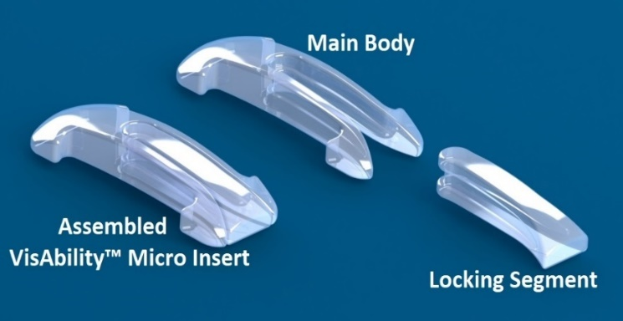 |  |  |  | 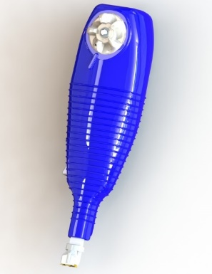
VisAbility™ Micro Inserts |  |  |  | VisAbility™ Scleratome
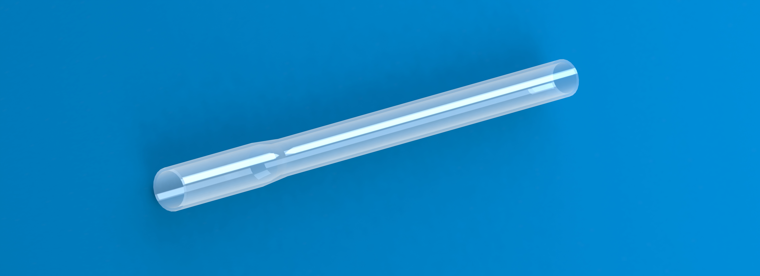
VisAbility™ Feeder Tube
The VisAbility™ Micro Insert System consists of the following components:
• VisAbility™ Micro Insert: A scleral implant intended to improve near vision in presbyopes.
• VisAbility™ Scleratome: Surgical instrument used for creating precisely positioned scleral tunnel incisions in which the VisAbility™ Micro Insert is placed.
• VisAbility™ Feeder Tube: Tubing used to assist in placing the VisAbility™ Micro Insert into the scleral tunnel.

The VisAbility™ Micro Insert is a curved scleral implant that is injection molded from polymethylmethacrylate (PMMA). Four (4) VisAbility™ Micro Inserts are placed in a single presbyopic eye to improve near vision.

The VisAbility™ Scleratome is a sterile, single-use, disposable device composed of titanium, stainless steel, and molded plastics. The VisAbility™ Scleratome is an accessory used to create the scleral tunnel incisions into which the VisAbility™ Micro Inserts are placed.

The VisAbility™ Feeder Tube is a sterile, single-use, disposable tube produced using a polytetrafluoroethylene (PTFE) extrusion and flaring process. The VisAbility™ Feeder tube is an accessory that is used to place the VisAbility™ Micro Insert into the scleral tunnel.
Additional Instrumentation (Reusable)

Numerous general surgical instruments are referenced in this IFU to be used performing the VisAbility™ Micro Insert procedure. The instruments referenced are all manufactured by Duckworth & Kent, a surgical instrument provider located in Baldock, England. A listing of all these ophthalmic instruments is found below.

Part Number | Description | How Used in Procedure
6-651 | Docking Station | Fixation of the globe. Also provides a “template” for desired tunnel location.
8-011 | Docking Station Actuation Tool | Screwdriver-like device for rotating the 4 fixation points on the Docking Station.
2-731 | Docking Station Forceps | Used to place and manipulate the Docking Station
6-194-2 | Shuttle | Mates with the Feeder Tube and Main Body to facilitate passage through the scleral tunnel.
9-864-1 | Barrel Marker | Used for marking the eye prior to peritomy and placement of the Docking Station
966-0030 | Removal Cutter | Used for Micro Insert removal.
6-098-3 | Spatula | Helpful for locating superior and inferior rectus muscles. Used to verify length of scleral tunnels.
2-729-3 | Shuttle Forceps | Used to grasp the Feeder Tube Assembly while feeding through the scleral tunnels.
2-729-1 | Main Body Loading Forceps | Used during pre-surgery preparation to place Main Body into the flared end of the Feeder Tube.
2-2-833S | Locking Segment Forceps | Grasps the Locking Segment for insertion into the Main Body after it has been placed into the tunnel.
9-588 | Burratto Adjustable Speculum | Lightweight, unobtrusive speculum for keeping lid open during the procedure
G19750 | Wescott Scissors – Blunt Tip | Create conjunctival incision. Provide some blunt dissection if required.
2-114E | Castroviejo Suturing Forceps 0.12mm | General fixation, manipulation, suturing.
2-135E | Colibri Forceps 0.12mm | General fixation, manipulation, suturing.
2-116E | Castroviejo Suturing Forceps 0.3mm | General fixation, manipulation, during suturing.

SUMMARY OF SAFETY AND CLINICAL PERFORMANCE
The complete summary of safety and clinical performance has been uploaded to EUDAMED database. It may be found with the following link (TO BE PROVIDED AFTER NOTIFIED BODY UPLOADS).
The VisAbility Micro Insert System meets its intended use providing a clinically significant improvement in near visual acuity in presbyopic patients.
A favorable safety profile has also been demonstrated, as mitigation and management of safety events related to the VisAbility Micro Insert System allows rapid resolution of any issues that may arise.

INDICATIONS FOR USE
The VisAbility™ Micro Insert is indicated for bilateral scleral implantation to improve unaided near vision in phakic, presbyopic patients between the ages of 45 and 60 years of age, who have a manifest spherical equivalent between -0.75 D and +0.50 D with less than or equal to 1.00 D of refractive cylinder in both eyes and require a minimum near correction of at least +1.25 D reading add.

EXPECTED BENEFITS AND CLINICAL PERFORMANCE
The clinical benefit of the VisAbility Micro Insert is the improvement in near vision without a compromise in distance vision, as evidenced by the clinical performance of achievement of DCNVA of 20/40 or better and a gain of ≥ 10 letters with no permanent loss of distance VA..

CONTRAINDICATIONS
Patients with any of the following are contraindicated for this procedure:
- Patients where either pupil has a baseline percent change from scotopic to photopic of less than 30%, or an absolute difference of less than 1.00 mm between scotopic and photopic pupil size as measured by the NeurOptics Pupillometer.
- Patients with ocular inflammation, chronic uveitis, or other recurrent anterior or posterior segment inflammatory conditions in either eye; patients with any ocular or systemic disease(s) posting a significant risk for ocular inflammation including but not limited to autoimmune disorders (e.g., rheumatoid arthritis, ankylosing spondylitis, Reiter’s syndrome, ulcerative colitis, Crohn’s disease, psoriasis, sarcoidosis, Behcet’s disease), infections (toxoplasmosis, cat-scratch fever, West Nile virus, syphilis, tuberculosis, herpes zoster, herpes simplex, adenovirus), ocular trauma, or gout.
- Patients with scleral thickness of less than 530 microns measured 3.5 to 4.0 mm posterior to the superior temporal quadrant limbus in either eye.
- Patients with a history of any prior intraocular procedure (e.g., corneal transplant, filtering procedures for glaucoma, vitrectomy, retinal detachment repair, cataract surgery) or any prior refractive procedure (e.g., LASIK, surface excimer, or incisional surgery) in either eye.
- Patients with any history of prior extraocular muscle surgery or orbital surgery.
- Patients with chronic ocular disease, including but not limited to corneal pathology, primary or secondary glaucoma, iritis, herpes simplex, uveitis, trachoma, ocular pemphigoid, Sjogren’s disease, uveal melanoma, Thyroid Related Immune Orbitopathy, or clinically significant retinal pathology in either eye.
- Patients with any acute ocular disease that has not been completely treated and resolved for at least 3 months such as conjunctivitis, blepharitis, chalazion, corneal abrasion, or keratitis in either eye.
- Patients with chronic systemic diseases which may affect the eye, including but not limited to diabetes, ulcerative colitis, systemic lupus erythematosus, Crohn’s disease, collagen vascular disease, rheumatoid arthritis, any bleeding diathesis, or systemic manifestations of HIV/AIDS. Any other uncontrolled systemic disease (e.g., hypertension, cancer, etc.) that could compromise the patient. Patients with chronic ocular surface disease, including but not limited to patients with a prior diagnosis of chronic dry eye syndrome based on tests such as but not limited to, corneal or conjunctival staining, Ocular Surface Disease Index symptom score or Schirmer tear testing.
- Use of any medication, with anti-coagulation effects, including but not limited to Coumadin, which could lead to excessive bleeding and that could make the surgical procedure more difficult.
- Note: Patients using anti-coagulant medications such as Coumadin, aspirin, or non-steroidal anti-inflammatory drug (NSAID) medication must discontinue the medication at least 10 days prior to surgery or longer until the anti-coagulant effect has returned to normal. It is recommended that written approval to discontinue these medications is obtained from the treating doctor prior to discontinuing this medication.
- Patients who are pregnant or nursing.
- Patients who are allergic to any of the medications used in the surgical procedure.

PRECAUTIONS
The following precautions should be observed:
 | Do not use the VisAbility™ Micro Inserts, Scleratome, or Feeder Tube beyond the expiration date indicated on the Product and/or carton label.
 | Check the integrity of the sterile barrier before use. Do not use the VisAbility™ Micro Inserts, Scleratome, or Feeder Tube if the outer container is opened or damaged.
 | Do not use these devices if the container shows evidence of exposure to dampness.
 | The VisAbility™ Micro Inserts, Scleratome, and Feeder Tube are single-use, disposable items. Do not re-use, reprocess, or re-sterilize these devices.  Reuse of these single use devices may result in serious injury, such as endophthalmitis. Resterilization could also modify the physical characteristics of the Micro Inserts, resulting in the inability to properly assemble in the scleral tunnel. The Scleratome blade could be damaged, resulting in improper tunnel formation, and other internal components might be damaged which would prevent proper functioning of the device when actuated.
- Re-use, re-processing, re-packaging, re-sterilization, or product modification voids any warranties written or implied.
- Use good surgical technique to prevent unnecessary trauma and risk to the patient.
- Do not use any irrigating solution which is not exclusively intended for ocular surgery. Other solutions may damage the VisAbility™ Micro Insert.
- Do not use any mydriatic or miotic medication prior to or during surgery that will affect the pupillary reaction to light.
- Avoid damaging the VisAbility™ Micro Insert with instruments that may scratch the surface.

WARNINGS
As with any surgical procedure, there is risk of complications from the VisAbility™ Micro Insert System procedure. These may include, but are not limited to the following:
Intraoperative Events
- Scleral perforation
- Scleral perforation with vitreous prolapse
Lids and Lashes
- Ptosis
- Clinically significant lid margin disease (e.g., blepharoconjunctivitis, blepharitis, meibomitis, meibomian gland dysfunction, etc.)
Cornea
- Corneal dellen
- Corneal abrasion
- Dry eye signs of corneal and/or conjunctival staining, etc., which may require prescription medication
- Corneal edema
- Corneal infiltrate or ulcer
Conjunctive/Sclera
- Conjunctival cyst
- Conjunctival thinning or erosion
- Moderate or severe conjunctival injection (redness) persisting beyond the postoperative healing phase (approximately 3 months or more)
- Subconjunctival hemorrhage

Anterior Segment, Iris, Lens
- Pupil abnormalities
- Grade 4 anterior segment ischemia (ASI) (corneal edema, anterior chamber reaction, and decreased pupil reactivity)
- Anterior chamber cells or flare
- Intraocular inflammation other than anterior chamber cells and flare (e.g., vitritis)
- Significant lens opacity formation
- Displaced or missing VisAbility™ Micro Insert
- Iris Atrophy
Intraocular Pressure (IOP)
- Hypotony (IOP < 6 mm Hg)
- Increase IOP > 10 mm Hg or IOP > 30 mm Hg
Best Corrected Distance Visual Acuity (BCDVA) Loss
- Decrease in BCDVA of either a temporary or persistent nature
Fundus
- Choroidal effusion
- Retinal detachment
- Retinal or vitreous hemorrhage
Secondary Surgical Intervention
- VisAbility™ Micro Insert removal
- Exposed VisAbility™ Micro Insert (lid or conjunctival exposure) or conjunctival retraction requiring conjunctival reapproximation
- Cataract surgery
Other
- Eye pain requiring oral prescription pain medication
- Allergic reactions to medication, devices, sutures, or anesthesia

CAUTIONS
Proper surgical technique is the responsibility of the individual physician following specific training.
- Each of 4 tunnels should be created solely with the VisAbility™ Scleratome positioned by the Docking Station. USE OF A MANUAL BLADE IS NOT RECOMMENDED FOR USE IN CREATING OR AUGMENTING ANY SCLERAL TUNNEL.
- If at any time, the physician observes the rectus muscles insertions nearer that 4.5 mm posterior to the limbus, consider aborting the procedure and closing the conjunctiva to avoid the risk of impinging upon the vasculature that supplies the anterior segment, thus decreasing the risk of anterior segment ischemia.
- Due to the potential for a detrimental effect on perfusion and/or scleral thickness, do not use bipolar and/or thermal cautery on the sclera during surgery.
- The Feeder Tube Assembly must be used when placing the Main Body in the scleral tunnel to avoid unintentional scleral perforation.

 | When advancing the Feeder Tube Assembly, or any instrument such as a Spatula, through the scleral tunnel, the leading edge of the Shuttle or other instrument must be directed upwards (anteriorly) along the roof of the tunnel to facilitate exiting from the tunnel and to avoid unintentional scleral perforation.
- While pulling the VisAbility™ Feeder Tube through the scleral tunnel, pay close attention that the Main Body does not begin to disinsert from the VisAbility™ Feeder Tube prematurely. Should disinsertion occur, do not attempt to reinsert the Main Body but rather, use forceps to pull the Feeder Tube through then reload the Main Body.
- The VisAbility™ Micro Inserts, Scleratome, and Feeder Tube are supplied sterilized for single-use only and should be opened under sterile conditions.

DISPOSAL OF DEVICES
The devices should be disposed of immediately after surgery according to hospital guidelines and applicable local regulations for biological waste.

Furthermore, the Scleratome should be disposed of in a sharps container, as it contains a blade (which should be fully retracted) as well as small tines on one end that may pose a threat to hospital personnel.

INTENDED USERS
The implantation of the VisAbility™ Micro Insert is limited to licensed physicians who have been trained by Refocus Group, Inc. in the VisAbility™ Micro Insert System Procedure.

INSTRUCTIONS FOR USE
The VisAbility™ Micro Insert System Procedure can be performed as an outpatient procedure by a physician as described and categorized in the steps below.

12.1 Preoperative loading of Feeder Tube Assemblies
Pre-operatively, four Feeder Tube Assemblies are assembled, typically by scrub technician by inserting a Main Body into the flared end of the Feeder Tube, and then inserting the Shuttle into the straight end of the Feeder Tube. A detailed description of this process is found below.

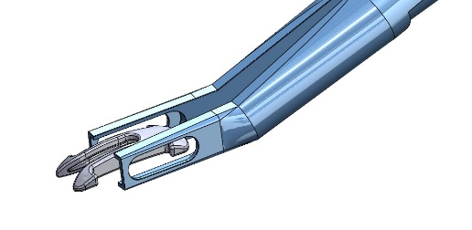  Figure 1 | 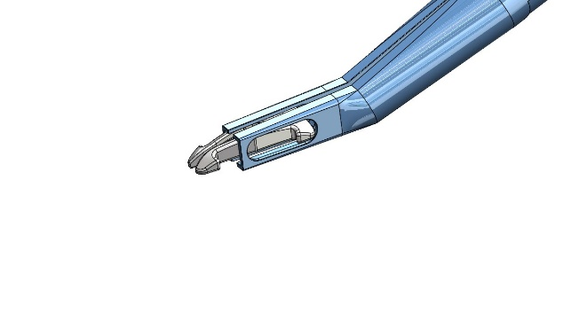  Figure 2
- Place a Main Body into the Main Body Loading Forceps with the solid end located to the back of the forceps side clearance slot. (Figure 1)
- Close the Main Body Loading Forceps. This will bring the Main Body legs together, facilitating insertion into the Feeder Tube. (Figure 2)

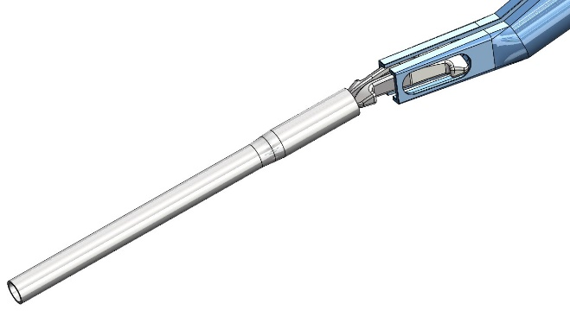  Figure 3 | 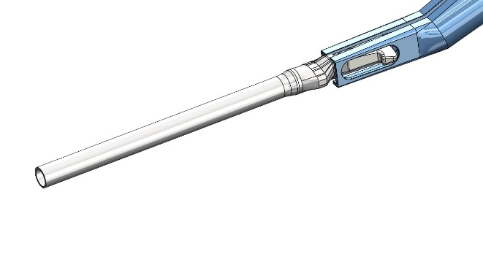  Figure 4
- Insert the Main Body legs into the flared end of the Feeder Tube. (Figure 3)
- Advance the Main Body into the Feeder Tube until the end of the Feeder Tube contacts the Main Body Loading Forceps. (Figure 4)
- Open the forceps and remove them from the Main Body.

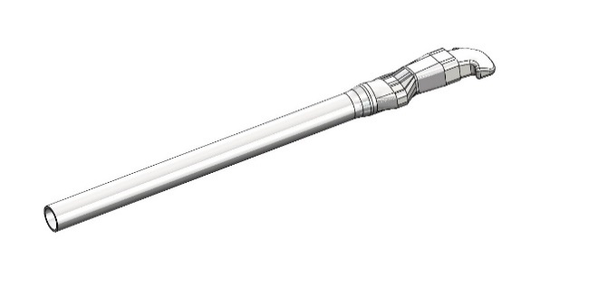  Figure 5 | 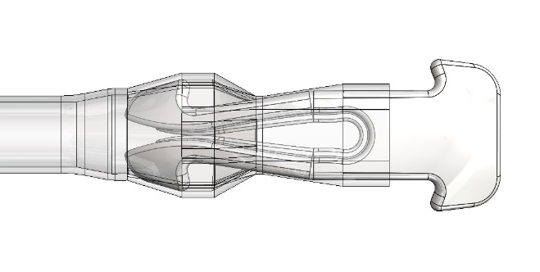  Figure 6
- Continue to advance the Main Body into the Feeder Tube (Figure 5) until center channel of the Main Body is covered. (Figure 6)

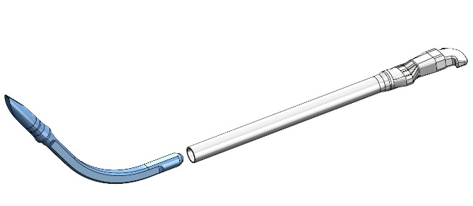  Figure 7 | 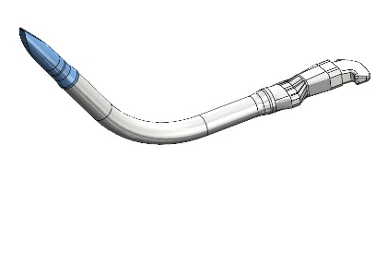  Figure 8
- Insert the Shuttle into the straight end of the Feeder Tube. Note orientation of the Main Body to the Shuttle. (Figure 7)
- Continue advancing the Shuttle until the Feeder Tube stops. The flexible Feeder Tube will conform to the Shuttle as shown. (Figure 8)

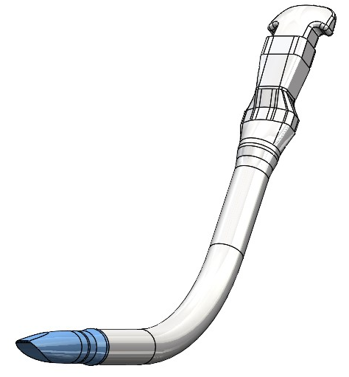  Figure 9 | 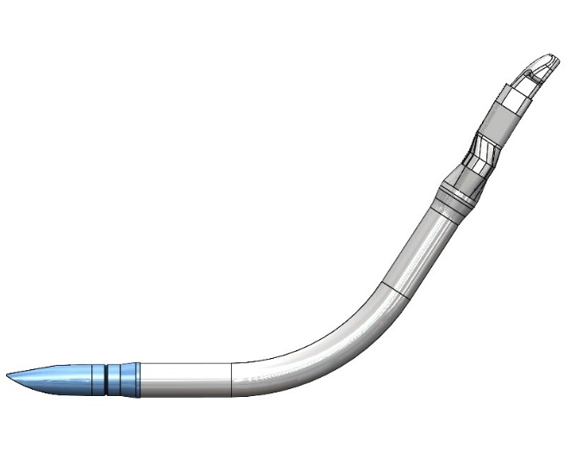  Figure 10
- The Feeder Tube Assembly is now ready for use. (Figure 9)
- Again, note the orientation of the Main Body to the Shuttle. (Figure 10)
The curvature of the Main Body and the Shuttle result in the letter “S”

12.2 Marking
Approximately 10 minutes prior to the procedure, instill a topical anesthetic such as proparacaine ophthalmic solution, or equivalent, in the eye(s). With the patient in the standing or seated position, and fixating on an object straight ahead, mark the limbus at 12:00 and 6:00 o’clock with a sterile gentian violet marker. Reinforce these marks as needed and place one drop of Brimonidine 0.1%, 0.15%, or equivalent on the patient’s operative eye(s). Have the patient close his or her eyes for 2 minutes.
In the operating room, with the patient’s vital signs monitored, use systemic relaxation as needed (e.g., Valium, Fentanyl, Versed, or a similar type of medication).

Clean the eye and the skin around the eye in the usual manner for sterile ocular surgery and drape the patient and their lids and lashes from the surgical field.

Use a locking eyelid Speculum that will hold the eyelids wide open.

Instill sterile 2% xylocaine drops without epinephrine, or equivalent, topically to the cornea and conjunctiva, drying off any excess.

Positively identify the superior and inferior rectus muscle insertions, and the anterior ciliary arteries accompanying them, by gently blanching the area with a flat Spatula, the flat handle of a forceps, or other alternative method such as capturing the edges of the muscle just behind its insertion. Confirm that the previously placed 6:00 and 12:00 o’clock limbal marks correspond to the axis of the center of the respective rectus muscle insertion or correct their position to this axis as needed.

On a relatively dry limbus, align the Barrel Marker positioning the barrel to the geometric limbus and rotate it to align the internal grooves with previously placed limbal marks. Place the Barrel Marker in its positioning slots and mark the eye.

12.3 Peritomy
Re‐instill sterile 2% xylocaine drops without epinephrine, or equivalent, topically to maintain good anesthesia.

Make two 3 mm or longer vertical conjunctival incisions approximately 0.5 mm from the limbus at the 3 and 9 o’clock positions using a 0.3 Forceps and Westcott Scissors – Blunt Tip.

Taking care not to tear the conjunctiva, utilize Westcott Scissors – Blunt Tip to bluntly dissect posteriorly into the sub‐Tenon’s space at an angle to avoid the horizontal plane of the medial and lateral recti muscles.

With a blunt cannula on a syringe containing sterile 2% xylocaine solution without epinephrine, or equivalent, enter the sub‐Tenon’s space posteriorly. Advance the cannula and then sweep the cannula toward the limbus. Inject approximately 0.25 cc of the sterile 2% xylocaine solution without epinephrine, or equivalent, in each of the 4 quadrants.

After the sub‐Tenon’s injection of anesthetic has been completed, perform a 360-degree limbal peritomy of the conjunctiva and Tenon’s capsule.

Upon completion of the peritomy, inspect the sclera near the limbus at the 3, 6, 9 and 12 o’clock positions for bare sclera in preparation for placement of the Docking Station. Utilize absorbent sticks or forceps if additional blunt dissection of the sclera is required.

CAUTION:
If after completing the conjunctival peritomy, the physician observes the insertions of the rectus muscles nearer than 4.5 mm posterior to the limbus, consider aborting the procedure and closing the conjunctiva to avoid the risk of impinging upon the vasculature that supplies the anterior segment, thus reducing the risk of anterior segment ischemia.

CAUTION:
Due to the potential of a detrimental effect on perfusion and/or scleral thickness, bipolar and/or thermal cautery should not be used during surgery.

12.4 Docking Station Placement
Place the Docking Station on the eye by holding the unit slightly above the eye with the Docking Station Forcep. Carefully drape the conjunctiva over the 4 corners and perimeter of the Docking Station to avoid engaging any conjunctiva in the helical twists.
Center the Docking Station on the geometric limbus by keeping the inside diameter of the unit concentric with the limbus. Maintain the desired rotational position of the unit by aligning both the 6 and 12 o’clock internal arrow points with the 6 and 12 o’clock limbal marks, and the docking channels with the oblique line marks from the Barrel Marker.

Once concentricity and rotational position have been satisfactorily achieved, use the Docking Station Actuation Tool to rotate each of the 4 fixation points clockwise 180˚ to their stop position, while pressing down on the Docking Station to engage the helical twists into the limbal sclera.

After fixation, visually confirm satisfactory x/y and rotational positioning, and verify sufficient four‐point fixation of the Docking Station by lightly proptosing the eye with gentle lifting of the unit. Reposition if necessary.

12.5 Scleral Tunnel Creation
Create each of 4 tunnels using the VisAbility™ Scleratome (Figure 11).
CAUTION:
Use of a manual blade is not recommended for use in creating or augmenting any scleral tunnel.
Create tunnels in the following sequence to facilitate hand positioning and ensure the superior temporal quadrant tunnel is created last, because the sclera in that quadrant typically is the thinnest on the eye:
- Inferior Nasal (IN),
- Superior Nasal (SN),
- Inferior Temporal (IT), and
- Superior Temporal (ST).
Beginning with the IN quadrant, rotate and proptose the eye to provide adequate exposure of the sclera. Confirm the sclera near the Docking Station is bare of any Tenon’s capsule tissue. Perform additional blunt dissection of any Tenon’s capsule tissue if required.

Prior to placing the VisAbility™ Scleratome, verify that its winding knob has been fully actuated.

Place the locating ridge of the VisAbility™ Scleratome adjacent to the corresponding channel in the Docking Station (Figure 12) and touch the blade guard to the surrounding edge. While maintaining this close position, bring the VisAbility™ Scleratome perpendicular to the sclera such that the footplate is flat to bare sclera (Figure 13).

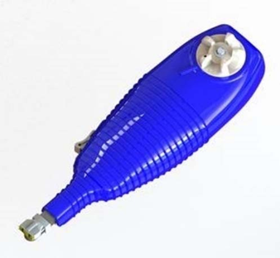 | 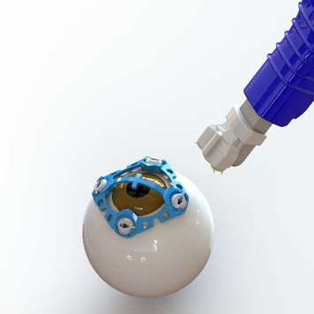
VisAbility™ Scleratome  Figure 11 | Distal End of VisAbility™ Scleratome  Figure 12
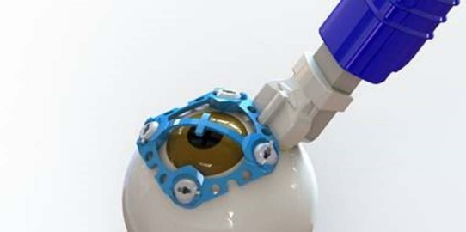

VisAbility™ Scleratome placement with Docking Station
Figure 13

With a balance of pressure with the VisAbility™ Scleratome and proptosis with the Docking Station, activate the VisAbility™ Scleratome by advancing the slide button downward toward the eye. A “click” should be heard which confirms actuation.

Confirm the length of each scleral tunnel created using a measuring Spatula. If any scleral tunnel length is less than 3.5 mm, consider NOT implanting the VisAbility™ Micro Insert in that quadrant. Do not attempt to create another scleral tunnel in the same quadrant.

CAUTION:
When advancing the measuring Spatula through the scleral tunnel, direct the leading tip upwards (anteriorly) along the roof of the tunnel to facilitate exiting from the tunnel and to avoid unintentional scleral perforation.

To minimize manipulation of the eye, a VisAbility™ Micro Insert (Figure 14) should be placed in each scleral tunnel made prior to proceeding to the creation of the next Scleral tunnel.

Re‐wind the knob of the VisAbility™ Scleratome prior to creation of the next scleral tunnel.

12.6 Implantation of the VisAbility™ Micro Insert
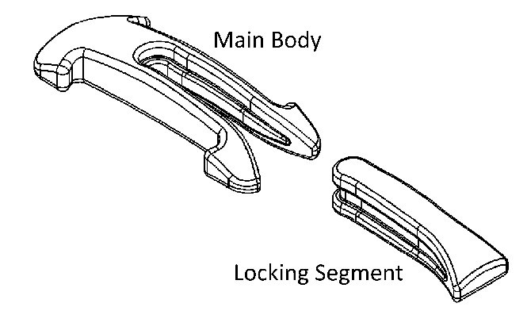

The VisAbility™ Micro Insert is a two-piece assembly, consisting of a Main Body and a Locking Segment.
Figure 14
Immediately after creating and verifying each tunnel, maintain fixation of the eye with the Docking Station and grasp the VisAbility™ Feeder Tube Assembly with the Shuttle Forceps approximately 12 mm from its leading edge. Insert the front end of the Shuttle into the scleral tunnel and advance the VisAbility™ Feeder Tube Assembly through the tunnel (Figure 15).
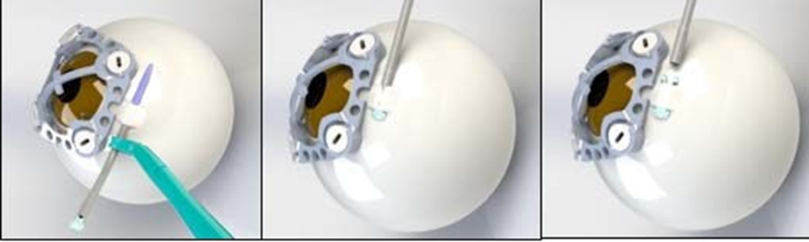
Implanting the VisAbility™ Micro Inserts
Figure 15 Figure 16 Figure 17
To facilitate hand positioning, enter the inferior quadrant tunnels (IN and IT) forehand from the inferior end of the tunnel. Enter the superior quadrant tunnels (SN and ST) backhand from the superior end of the tunnel.
CAUTION:
When advancing any instrument including the VisAbility™ Feeder Tube Assembly through the scleral tunnel, the leading tip of the instrument must be directed upwards (anteriorly) along the roof of the tunnel to facilitate exiting from the tunnel and to avoid unintentional scleral perforation.
After 3 mm or more of the Shuttle has exited the tunnel, grasp the exited VisAbility™ Feeder Tube and pull the assembly until the feet of the Main Body have exited the tunnel (Figure 16).
CAUTION:
While pulling the VisAbility™ Feeder Tube Assembly through the scleral tunnel, pay close attention that the Main Body enters the scleral tunnel in the proper orientation and does not begin to disinsert from the VisAbility™ Feeder Tube prematurely. If the Main Body disinserts from the VisAbility™ Feeder Tube, do not attempt to push the Main Body through the scleral tunnel but rather safely back it out of the tunnel, reload it and attempt the pass again.
Replace all twisted or crimped tubing prior to use. Twisted or crimped tubing may make device placement more difficult.
After the feet of the Main Body have exited the tunnel, continue to pull the VisAbility™ Feeder Tube to disconnect it from the Main Body and allow the compressed feet to open, effectively locking the Main Body into the tunnel (Figure 17).
Using Locking Segment Forceps, grasp the top edges of the Locking Segment at the midpoint and guide it into the receiving slot of the Main Body. Use these same Locking Segment Forceps to then clasp along the length of the Main Body to compress and mate the Locking Segment into the Main Body. A snap‐like action will be apparent when the Locking Segment has been properly placed. In addition, the outer edge of the assembled VisAbility™ Micro Insert will line up flush and smooth, and the rails of the VisAbility™ Micro Insert will not show any gap.
Repeat tunnel creation and implantation for each of the remaining 3 quadrants in the order of SN, IT, and ST as noted above.

12.7 Docking Station Removal
Using the Docking Station Actuation Tool, rotate each of the 4 fixation points of the Docking Station counterclockwise 180˚ to their stop. This disengages the helical twists from the limbal sclera, and completely unlocks the device from the eye. Once free of fixation, carefully lift the Docking Station from the eye to avoid causing any corneal abrasion with the underside helical twists.
After lifting the unit from the eye, rinse away any excess clotted blood in the field. Reapply sterile 2% xylocaine drops without epinephrine, or equivalent, topically to maintain good anesthesia as needed.

12.8 Conjunctival Closure
Fibrin sealant may be utilized as an adjunct to hemostasis prior to conjunctival closure. Use a minimal amount of fibrin sealant, as excessive amounts may migrate over the cornea, requiring subsequent removal. Bring the conjunctiva into position to approximate where it will need to be located when closed. Use a 9‐0 braided Vicryl suture, or equivalent, with a modified mattress technique. Starting nasally, close at the 3 and 9 o’clock positions as needed, such as using a 3 mm scleral bite tangential to the limbus, and then a 4‐5 mm conjunctival bite at the 6 and 12 o’clock positions, as needed.
Care must be taken to ensure a smooth, uniform, minimally wrinkled, conjunctival closure for patient comfort post‐op.

CAUTION:
Deviation from this suture technique may result in conjunctival retraction and subsequent segment exposure requiring reapproximation.

12.9 After Conjunctival Closure
At the completion of the surgery, place a removable silicone punctal plug in the inferior punctum. Instill an initial dose of antibiotic drops such as moxifloxacin ophthalmic solution, or equivalent, and steroid drops such as prednisolone acetate 1% ophthalmic suspension, or equivalent, in the eye. Instruct the patient to keep their eyes closed and use ice compresses to decrease swelling.

12.10 Post-Operative Care
Following surgery, physicians should adhere to the following guidelines of topical ophthalmic medications and care:
- Evaluate pupil functionality postoperatively using a NeurOptics Pupillometer, or similar device, every 15 to 30 minutes until the percent pupil constriction reading is at least 25%. A second, confirmatory reading of 25% or greater may be taken as soon as 5 minutes after the first reading. If 2 pupil constriction readings of at least 25% are not achieved within the first 4 hours after surgery, commence preparation for removal of the VisAbility™ Micro Inserts. The physician must remove all 4 VisAbility™ Micro Inserts no later than 6 hours after the implantation surgery if the 2 pupil constriction readings of at least 25% are not achieved within 6 hours postoperatively.
- During the first week after the surgery, antibiotic drops such as moxifloxacin ophthalmic solution, or equivalent, and topical steroid drops such as Lotemax gel, or equivalent, should be instilled in the eye. Additionally, NSAIDs such as topical nepafenac ophthalmic suspension, or equivalent, and/or oral medications such as naproxen or acetaminophen with codeine, or equivalent, may be given as needed for pain during this time. Preservative‐free artificial tears and/or ointment should be used as often as needed for dryness and comfort following surgery.

PROCEDURE TO SURGICALLY REMOVE THE VISABILITY™ MICRO INSERT
The VisAbility™ Micro Insert System removal procedure, if required, must be performed by a trained physician as described below.
- Magnification of the surgical area at a surgical microscope is advised.
- Preoperative sterile prep and drape is required.
- Apply topical anesthesia with sterile 2% xylocaine drops without epinephrine, or equivalent, to the operative eye requiring VisAbility™ Micro Insert removal. A drop of Brimonidine 0.1% or 0.15%, or equivalent, may also be used to decrease bleeding.
- In the immediate post‐operative period, remove the sutures holding the conjunctiva and move the conjunctiva posteriorly to expose the implants.
  - If the conjunctiva has already healed, use Westcott Scissors – Blunt Tip or a sterile sharp blade such as a 15° ophthalmic sharp, 18-to-21-gauge hollow injection needle, or equivalent, to make a small (~2mm) scratch down incision of the conjunctiva over both exposed ends of the Micro Insert.
- Use forceps, such as a 0.12 Forceps, to further expose the ends of the VisAbility™ Micro Insert from the overlying conjunctiva.
- Once the ends of the Micro Insert are un-encapsulated (Figure 18), utilize the Removal Cutter to remove both stabilization feet from one end (Figure 19).
- Carefully remove the severed pieces of the Micro Insert from both the eye and the Removal Cutter. Verify the stabilization feet are fully removed from the Micro Insert.
- Using toothed forceps, grasp the uncut end of the Micro Insert, and pull it through the tunnel with a slight twisting motion to remove them from the eye (Figure 20).

Removing the VisAbility™ Micro Inserts
Figure 18 Figure 19 Figure 20
Repeat for each VisAbility™ Micro Insert requiring removal.
After completing removal of all required VisAbility Micro Inserts, the scleral and conjunctival areas that have been opened should be assessed to see if they will heal primarily, if they need to be inflated with an intra tenon’s injection of BSS or need to be sutured with an appropriate gauge suture.
An initial dose of antibiotic drops such as moxifloxacin ophthalmic solution or equivalent and steroid drops such as prednisolone acetate 1% ophthalmic suspension or equivalent should be instilled in the eye.
A light dressing may be applied to keep the eyes closed overnight for patient comfort.
During the first week after the surgery, a topical antibiotic (e.g. moxifloxacin or equivalent) should be used as directed. During the first month after surgery, for routine postoperative steroid taper, prednisolone acetate 1% should be used 6x/day for 2 weeks, 4x/day for 2 weeks, 2x/day for 2 weeks. Oral pain medications may be given as needed for pain.

ENVIRONMENTAL HAZARDS
If any of the following occurs, the specific product will be disqualified for clinical use and should be returned to the manufacturer:
- Damage to labeling that prevents clear identification of print.
- Damaged Tyvek seal.
- Crushed, deformed, or discolored package.
- Any foreign material or moisture in the package.

CLINICAL STUDY INFORMATION
A U.S. pivotal clinical trial was conducted in the United States to establish the safety and effectiveness of the VisAbility™ Micro Insert System for the improvement of near visual acuity in presbyopic patients.
This study was a prospective multicenter clinical trial that enrolled 360 eligible subjects ranging in age between 45 and 60 years with distance corrected near visual acuity (DCNVA) and uncorrected near visual acuity (UCNVA) of 20/50 to 20/80 (inclusive). Subjects were enrolled at up to 13 clinical sites with no site enrolling, or determining eligible, more than 20% of the total cohort of 360 eligible subjects.
Subjects were consented and screened based on medical history, ocular history, and visual acuity criteria. Subjects were required to satisfy specific inclusion and exclusion criteria during a baseline examination to be eligible for surgery. Subjects were implanted with the VisAbility™ Micro Insert in the dominant eye, which was designated as the primary eye. The fellow eye was implanted no sooner than 14 days after the primary eye, and only in the absence of unresolved adverse events in the primary eye. The subject’s primary eye was examined at one day, one week and at 1, 2, 3, 6, 12, 18, and 24 months post‐operatively. The fellow eye was also examined at one day, one week, and 1, 2, 3, 6, 12, 18, and 24 months postoperatively.
This study also included a 60‐subject randomized controlled sub‐study at 3 investigational sites. Eligible subjects enrolled at these sites were randomized (1:1 ratio) to a surgery group or a control group. Subjects assigned to the randomized surgery group were implanted and followed for 24months in the same manner as the larger non‐randomized surgery group. Subjects randomized to the control group were followed for 6 months and were eligible to undergo VisAbility™ Micro Insert surgery after completion of the 6‐month observation period. Subjects who elected surgery were followed for 24 months in accordance with the same schedule as the non‐randomized surgery group. Randomized control group subjects who did not chose to undergo VisAbility™ Micro Insert surgery at the end of the 6‐month observation period were exited from the study at that time.
The reporting period for the primary safety and efficacy endpoints was the 12‐month study visit, with patient examination and data collection through 24‐months. Data from this clinical trial were the basis for the PMA approval decision and a summary of the clinical trial outcomes is presented below for both 12 and 24 months.

15.1 Effectiveness
The primary effectiveness endpoint consisted of 2 co‐primary endpoints as follows:
- Co‐primary Endpoint 1: Achievement of DCNVA 20/40 or better and gain ≥ 10 letters DCNVA in 75% of the primary eyes of bilaterally implanted subjects at 12 months.
  - The primary eye was defined as the dominant eye. This co‐primary endpoint was also prespecified to be evaluated at 24 months.
- Co‐primary Endpoint 2: Achievement of a statistically significant (one‐sided p <.005) difference in the proportion of eyes with DCNVA 20/40 or better and gain of ≥ 10 letters in subjects randomized to treatment versus deferred surgery as part of the randomized sub‐study. This endpoint was evaluated at 6 months.
Table 1a provides the primary, best‐case, and worst‐case results for the first Co-Primary Effectiveness Endpoint result of all bilaterally implanted subjects at 12 months. Table 1b also provides the primary, best-case, and worst‐case results for achievement of DCNVA 20/40 or better and gain of ≥ 10 letters DCNVA at 24 months, showing that subjects had continued improvement in near visual acuity.
Table 1a
First Co‐Primary Effectiveness Endpoint of Bilaterally Implanted Subjects
DCNVA ≥ 20/40 and Gain of ≥ 10 Letters at 12 Months
Primary Eyes
≥≥  Primary Analysis¹  n/N (%), 95% CI⁴ |  | Best Case  Sensitivity Analysis² | Worst Case  Sensitivity Analysis³
 |  | n/N (%), 95% CI⁴ | n/N (%), 95% CI⁴
275/340 (80.9%)  (76.3%, 84.9%) |  | 282/348 (81.0%)  (76.5%, 85.0%) | 277/348 (79.6%)  (75.0%, 83.7%)
¹ | Explants at or before Month 12 were imputed as failures. Other subjects with missing Month 12 values were excluded.
² | Explants at or before Month 12 were imputed as failures. For other subjects with missing Month 12 value, the best value from the protocol scheduled visits at Month 1 to later (1-month, 2-month, 3-month, or 6-month) was used. If no data were observed between Month 1 and Month 12, the subjects were imputed as successes.
³ | Explants at or before Month 12 were imputed as failures. For other subjects with missing Month 12 value, the worst value from the protocol scheduled visit at Month 1 to later (1-month, 2-month, 3-month, or 6-month) was used. If no data were observed between Month 1 and Month 12, the subjects were imputed as failures.
⁴ | Exact binomial 95% confidence interval (CI)

Table 1b
First Co‐Primary Effectiveness Endpoint of Bilaterally Implanted Subjects
DCNVA ≥ 20/40 and Gain of ≥ 10 Letters at 24 Months
Primary Eyes
Primary Analysis¹  n/N (%), 95% CI⁴ |  | Best Case  Sensitivity Analysis² | Worst Case  Sensitivity Analysis³
 |  | n/N (%), 95% CI⁴ | n/N (%), 95% CI⁴
287/335 (85.7%)  (81.5%, 89.2%) |  | 297/348 (85.3%)  (81.2%, 88.9%) | 289/348 (83.0%)  (78.7%, 86.8%)
¹ | Explants at or before Month 24 were imputed as failures. Other subjects with missing Month 24 values were excluded. One subject (00922032) excluded due to IOL implantation.
² | Explants at or before Month 24 were imputed as failures. For other subjects with missing Month 24 value, the best value from the protocol scheduled visits at Month 1 to later (1-month, 2-month, 3-month, 6-month, 12-month, or 18-month) was used. If no data were observed between Month 1 and Month 24, the subjects were imputed as successes.
³ | Explants at or before Month 24 were imputed as failures. For other subjects with missing Month 24 value, the worst value from the protocol scheduled visit at Month 1 to later (1-month, 2-month, 3-month, 6-month, 12-month, or 18-month) was used. If no data were observed between Month 1 and Month 24, the subjects were imputed as failures.
⁴ | Exact binomial 95% confidence interval (CI)

The second co‐primary effectiveness endpoint was based on data from the randomized comparative sub‐study and was designed to assess the potential differences of randomized group allocation and/or site 6‐month responder rates. A logistic regression analysis examining the following was performed:
- Treatment effect (the randomized immediate surgery group and the randomized deferred control group at that same site),
- Study site effect (site by site success rate comparison), and
- Site by treatment interaction.
Since there was a significant difference (p ≤ 0.15) in treatment effect, and a significant interaction effect between study site effect and treatment effect (p ≤ 0.15), the 6‐month responder rate for each study group and the difference in the 6‐month responder rates between the 2 randomized groups (P_{treatment} ‐ P_{deferred}) were also summarized by each study site as shown in Table 2

Table 2
Second Co‐Primary Effectiveness Endpoint at 6 Months by Site
Randomized Substudy
Site | Deferred Treatment Group  (31 Randomized Eyes) |  |  |  | Immediate Treatment Group  (29 Randomized Eyes)
Site | N | 20/40 or Better  And  Gain of ≥10 Letters  n (%) |  | 95% CI | N | 20/40 or Better  and  Gain of ≥10 Letters  n (%) | 95% CI³
003 | 12 | 0 (0.0%) |  | 0.0%, 26.5% | 12 | 11 (91.7%) | 61.5%, 99.8%
007 | 10 | 1 (10.0%) |  | 0.3%, 44.5% | 10 | 2 (20.0%) | 2.5%, 55.6%
008 | 7 | 1 (14.3%) |  | 0.4%, 57.9% | 6 | 5 (83.3%) | 35.9%, 99.6%
Logistic Regression
Treatment p‐value |  |  | <.001
Site p‐value |  |  | 0.269
Treatment‐by‐Site p‐value |  |  | 0.084
Gail‐Simon p‐value |  |  | 0.750
CMH p‐value |  |  | <.001

Additional effectiveness analyses were performed which included DCNVA and UCNVA.
Preoperatively, less than 1% (2/360) of the bilaterally implanted study subjects had DCNVA 20/40 or better in the primary eye (Table 3). Per the study design, 6‐month observation data were used at the baseline analysis for deferred treatment randomized study subjects. This accounts for the 2 subjects who met the study criteria at the initial baseline. By 1 month postoperative, 68.8% (238/346) of eyes achieved DCNVA 20/40 or better in the primary eye and 91.4% (310/339) of primary eyes achieved DCNVA of 20/40 or better at 12 months. Additionally, 77.0% (261/339) of primary eyes had DCNVA of 20/32 at 12 months. Similar outcomes were observed at 24 months with 94.5% (312/330) of subjects achieving 20/40 or better in the primary eye. In addition, at 24 months postoperative 78.2% (258/330) of subjects achieved a DCNVA of 20/32 or better.
Table 3
DCNVA in Primary Eyes of Bilaterally Implanted Subjects Over Time
 | Preop N =348 | Month 1  N = 347 | Month 2  N = 340 | Month 3  N = 342 | Month 6  N = 339 | Month 12  N = 339 | Month 18  N = 321 | Month 24  N = 331
n (Reported) | 348 | 346 | 340 | 341 | 338 | 339 | 321 | 330
20/16 or better | 0  (0.0%) | 6  (1.7%) | 8  (2.4%) | 9  (2.6%) | 10  (3.0%) | 9  (2.7%) | 8  (2.5%) | 16  (4.8%)
20/20 or better | 0  (0.0%) | 20  (5.8%) | 31  (9.1%) | 39  (11.4%) | 53  (15.7%) | 84  (24.8%) | 73  (22.7%) | 86  (26.1%)
20/25 or better | 0  (0.0%) | 77  (22.3%) | 104  (30.6%) | 124  (36.4%) | 145  (42.9%) | 182  (53.7%) | 168  (52.3%) | 187  (56.7%)
20/32 or better | 1  (0.3%) | 148  (42.8%) | 178  (52.4%) | 201  (58.9%) | 236  (69.8%) | 261  (77.0%) | 256  (79.8%) | 258  (78.2%)
20/40 or better | 2  (0.6%) | 238  (68.8%) | 246  (72.4%) | 263  (77.1%) | 286  (84.6%) | 310  (91.4%) | 295  (91.9%) | 312  (94.5%)
20/50 or better | 125  (35.9%) | 304  (87.9%) | 299  (87.9%) | 318  (93.3%) | 317  (93.8%) | 327  (96.5%) | 311  (96.9%) | 327  (99.1%)
20/63 or better | 269  (77.3%) | 334  (96.5%) | 332  (97.6%) | 334  (97.9%) | 331  (97.9%) | 337  (99.4%) | 321  (100.0%) | 330  (100.0%)
20/80 or better | 348  (100.0%) | 344  (99.4%) | 337  (99.1%) | 341  (100.0%) | 337  (99.7%) | 339  (100.0%) | 321  (100.0%) | 330  (100.0%)
20/100 or better | 348  (100.0%) | 345  (99.7%) | 339  (99.7%) | 341  (100.0%) | 338  (100.0%) | 339  (100.0%) | 321  (100.0%) | 330  (100.0%)
20/125 or better | 348  (100.0%) | 346  (100.0%) | 340  (100.0%) | 341  (100.0%) | 338  (100.0%) | 339  (100.0%) | 321  (100.0%) | 330  (100.0%)
20/160 or better | 348  (100.0%) | 346  (100.0%) | 340  (100.0%) | 341  (100.0%) | 338  (100.0%) | 339  (100.0%) | 321  (100.0%) | 330  (100.0%)
20/200 or better | 348  (100.0%) | 346  (100.0%) | 340  (100.0%) | 341  (100.0%) | 338  (100.0%) | 339  (100.0%) | 321  (100.0%) | 330  (100.0%)
Not Reported | 0 | 1 | 0 | 1 | 1 | 0 | 0 | 1

Percentage is based on the number of eyes reported with data.
UCNVA 20/40 or better was achieved in the primary eyes of 81.4% (276/339) of the bilaterally implanted subjects at 12 months, 86.0% (276/321) at 18 months, and 88.1% (290/329) at 24 months (Table 4). In contrast, less than 1% of primary eyes (2/360) had UCNVA 20/40 or better preoperatively. Importantly, UCNVA 20/40 in the primary eye was achieved by 79.8% of study subjects starting at 3 months, increasing to 87.2% by 24 months.

Table 4
UCNVA in Primary Eyes of Bilaterally Implanted Subjects Over Time
 | Preop N =348 |  | Month 3  N = 342 | Month 6  N = 339 | Month 12  N = 339 | Month 18  N = 321 | Month 24  N = 331
n (Reported) | 348 |  | 341 | 338 | 339 | 321 | 329
20/16 or better | 0(0.0%) |  | 8  (2.3%) | 12  (3.6%) | 5  (1.5%) | 10  (3.1%) | 17  (5.2%)
20/20 or better | 0(0.0%) |  | 38  (11.1%) | 46  (13.6%) | 55  (16.2%) | 54  (16.8%) | 73  (22.2%)
20/25 or better | 0(0.0%) |  | 116  (34.0%) | 122  (36.1%) | 136  (40.1%) | 136  (42.4%) | 137  (41.6%)
20/32 or better | 1(0.3%) |  | 200  (58.7%) | 215  (63.6%) | 233  (68.7%) | 217  (67.6%) | 224  (68.1%)
20/40 or better | 2(0.6%) |  | 274  (80.4%) | 273  (80.8%) | 276  (81.4%) | 276  (86.0%) | 290  (88.1%)
20/50 or better | 92(26.4%) |  | 313  (91.8%) | 312  (92.3%) | 312  (92.0%) | 306  (95.3%) | 313  (95.1%)
20/63 or better | 225(64.7%) |  | 337  (98.8%) | 325  (96.2%) | 333  (98.2%) | 317  (98.8%) | 324  (98.5%)
20/80 or better | 348(100.0%) |  | 341  (100.0%) | 331  (97.9%) | 337  (99.4%) | 319  (99.4%) | 327  (99.4%)
20/100 or better | 348(100.0%) |  | 341  (100.0%) | 336  (99.4%) | 338  (99.7%) | 320  (99.7%) | 328  (99.7%)
20/125 or better | 348(100.0%) |  | 341  (100.0%) | 338  (100.0%) | 339  (100.0%) | 321  (100.0%) | 329  (100.0%)
20/160 or better | 348(100.0%) |  | 341  (100.0%) | 338  (100.0%) | 339  (100.0%) | 321  (100.0%) | 329  (100.0%)
20/200 or better | 348(100.0%) |  | 341  (100.0%) | 338  (100.0%) | 339  (100.0%) | 321  (100.0%) | 329  (100.0%)
Not Reported | 0 |  | 1 | 1 | 0 | 0 | 2

Percentage is based on the number of eyes reported with data.
Binocular UCNVA in Bilaterally Implanted Subjects is presented in Table 5. Preoperatively, only 2.0% (7/348) of subjects had binocular UCNVA of 20/25 or better, however, by 12 months 68.9.% (235/341) of subjects had improved to 20/25 or better. At 18 months, 73.3% (239/326) of subjects had UCNVA 20/25 or better and 72.6% (239/331) had UCNVA 20/25 or better at 24 months postoperative.
By 24 months, 96.0% (316/329) of bilaterally implanted subjects achieved binocular UCNVA of 20/40 or better, and 89.4%% (294/329) achieved 20/32 or better.

Table 5
Binocular UCNVA in Bilaterally Implanted Subjects Over Time
 | Preop N = 348 | Month 3  N = 337 | Month 6  N = 339 | Month 12  N = 341 | Month 18  N = 326 | Month 24  N = 331
n (Reported) | 348 | 337 | 338 | 341 | 326 | 329
20/16 or better | 0  (0.0%) | 33  (9.8%) | 29  (8.6%) | 35  (10.3%) | 35  (10.7%) | 29  (8.8%)
20/20 or better | 2  (0.6%) | 109  (32.3%) | 104  (30.8%) | 107  (31.4%) | 114  (35.0%) | 126  (38.3%)
20/25 or better | 7  (2.0%) | 229  (68.0%) | 221  (65.4%) | 235  (68.9%) | 239  (73.3%) | 239  (72.6%)
20/32 or better | 22  (6.3%) | 286  (84.9%) | 282  (83.4%) | 300  (88.0%) | 293  (89.9%) | 294  (89.4%)
20/40 or better | 96  (27.6%) | 318  (94.4%) | 312  (92.3%) | 328  (96.2%) | 315  (96.6%) | 316  (96.0%)
20/50 or better | 231  (66.4%) | 336  (99.7%) | 330  (97.6%) | 333  (97.7%) | 322  (98.8%) | 324  (98.5%)
20/63 or better | 329  (94.5%) | 337  (100.0%) | 337  (99.7%) | 340  (99.7%) | 324  (99.4%) | 327  (99.4%)
20/80 or better | 348  (100.0%) | 337  (100.0%) | 338  (100.0%) | 341  (100.0%) | 326  (100.0%) | 329  (100.0%)
20/100 or better | 348  (100.0%) | 337  (100.0%) | 338  (100.0%) | 341  (100.0%) | 326  (100.0%) | 329  (100.0%)
20/125 or better | 348  (100.0%) | 337  (100.0%) | 338  (100.0%) | 341  (100.0%) | 326  (100.0%) | 329  (100.0%)
20/160 or better | 348  (100.0%) | 337  (100.0%) | 338  (100.0%) | 341  (100.0%) | 326  (100.0%) | 329  (100.0%)
20/200 or better | 348  (100.0%) | 337  (100.0%) | 338  (100.0%) | 341  (100.0%) | 326  (100.0%) | 329  (100.0%)
Not Reported | 0 | 0 | 1 | 0 | 0 | 2

Percentage is based on the number of eyes reported with data.
At baseline, none of the subjects in either treatment arm of the randomized substudy (immediate or deferred treatment) had DCNVA of 20/40 or better (Table 6). Postoperatively, 75.0% (21/28) and 76.0% (19/25) of the immediate treatment group had improved to 20/40 or better at 3 months and 6 months, respectively. In the deferred treatment group, no subject improved to 20/40 or better at 3 months and 3/29 (10.3%) improved to 20/40 or better at 6 months.

Table 6
DCNVA for Primary Eyes in the Randomized Substudy
 | Deferred Treatment Group  (31 Randomized Eyes) |  |  | Immediate Treatment Group  (29 Randomized Eyes)
 | Baseline  N = 31 | Month 3  N = 29 | Month 6  N = 29 | Preop  N = 29 | Month 3  N = 28 | Month 6  N = 25
n (Reported) | 31 | 29 | 29 | 29 | 28 | 25
20/16 or better | 0 (0.0%) | 0 (0.0%) | 0 (0.0%) | 0 (0.0%) | 0 (0.0%) | 0 (0.0%)
20/20 or better | 0 (0.0%) | 0 (0.0%) | 0 (0.0%) | 0 (0.0%) | 1 (3.6%) | 2 (8.0%)
20/25 or better | 0 (0.0%) | 0 (0.0%) | 0 (0.0%) | 0 (0.0%) | 4 (14.3%) | 7 (28.0%)
20/32 or better | 0 (0.0%) | 0 (0.0%) | 1 (3.4%) | 0 (0.0%) | 12 (42.9%) | 13 (52.0%)
20/40 or better | 0 (0.0%) | 0 (0.0%) | 3 (10.3%) | 0 (0.0%) | 21 (75.0%) | 19 (76.0%)
20/50 or better | 5 (16.1%) | 5 (17.2%) | 7 (24.1%) | 7 (24.1%) | 25 (89.3%) | 25 (100.0%)
20/63 or better | 17 (54.8%) | 16 (55.2%) | 17 (58.6%) | 19 (65.5%) | 27 (96.4%) | 25 (100.0%)
20/80 or better | 31 (100.0%) | 26 (89.7%) | 29 (100.0%) | 29 (100.0%) | 28 (100.0%) | 25 (100.0%)
20/100 or better | 31 (100.0%) | 29 (100.0%) | 29 (100.0%) | 29 (100.0%) | 28 (100.0%) | 25 (100.0%)
20/125 or better | 31 (100.0%) | 29 (100.0%) | 29 (100.0%) | 29 (100.0%) | 28 (100.0%) | 25 (100.0%)
20/160 or better | 31 (100.0%) | 29 (100.0%) | 29 (100.0%) | 29 (100.0%) | 28 (100.0%) | 25 (100.0%)
20/200 or better | 31 (100.0%) | 29 (100.0%) | 29 (100.0%) | 29 (100.0%) | 28 (100.0%) | 25 (100.0%)
Not Reported | 0 | 0 | 0 | 0 | 0 | 0

Percentage is based on the number of eyes reported with data.

15.2 Safety
The analysis of safety was based on the full cohort of 360 subjects who underwent VisAbility™ Micro Insert implantation. The key safety outcomes for this study are presented in Tables 7 and 8. Ocular and non‐ocular adverse events are reported in Tables 9 and 10. There were no serious ocular events in this clinical trial. Additional safety outcomes are presented in Table 11.
Table 7 shows the best corrected distance vision over time for all implanted eyes. Early temporary postoperative decreases in BCDVA were due to ocular surface disruption.
No eye experienced persistent loss of 2 or more lines of BCDVA; however, ten eyes of nine patients did experience a transient decrease of 2 or more lines at 3 months or later which, per protocol, was considered an adverse event.
In 5 of the 10 eyes, decreased visual acuity was associated with ocular surface findings that resolved following treatment.
Ocular surface findings—resolved following treatment-5 eyes
- corneal abrasion-1 eye
- hypertensive optic neuropathy-1 eye
- cataract-2 eyes
- unknown etiology-1 eye—resolved by next visit without treatment
- In all cases, the loss of BCDVA resolved by the next study visit interval.
Table 7
BCDVA Over Time
Safety Cohort
 | Preop  N = 708 | 1 Week  N = 702 | Month 1  N = 698 | Month 2  N = 691 | Month 3  N = 689 | Month 6  N = 686 | Month 12  N = 687 | Month 18  N = 652 | Month 24  N = 668
n (Reported) | 708 | 702 | 696 | 691 | 688 | 684 | 687 | 652 | 668
20/16 or better | 449  (63.4%) | 372  (53.0%) | 442  (63.5%) | 494  (71.5%) | 533  (77.5%) | 544  (79.5%) | 581  (84.6%) | 558  (85.6%) | 552  (82.6%)
20/20 or better | 708  (100.0%) | 642  (91.5%) | 676  (97.1%) | 676  (97.8%) | 684  (99.4%) | 682  (99.7%) | 683  (99.4%) | 647  (99.2%) | 665  (99.6%)
20/25 or better | 708  (100.0%) | 691  (98.4%) | 696  (100.0%) | 690  (99.9%) | 687  (99.9%) | 684  (100.0%) | 687  (100.0%) | 652  (100.0%) | 668  (100.0%)
20/32 or better | 708  (100.0%) | 699  (99.6%) | 696  (100.0%) | 691  (100.0%) | 687  (99.9%) | 684  (100.0%) | 687  (100.0%) | 652  (100.0%) | 668  (100.0%)
20/40 or better | 708  (100.0%) | 700  (99.7%) | 696  (100.0%) | 691  (100.0%) | 687  (99.9%) | 684  (100.0%) | 687  (100.0%) | 652  (100.0%) | 668  (100.0%)
20/50 or better | 708  (100.0%) | 701  (99.9%) | 696  (100.0%) | 691  (100.0%) | 688  (100.0%) | 684  (100.0%) | 687  (100.0%) | 652  (100.0%) | 668  (100.0%)
20/63 or better | 708  (100.0%) | 702  (100.0%) | 696  (100.0%) | 691  (100.0%) | 688  (100.0%) | 684  (100.0%) | 687  (100.0%) | 652  (100.0%) | 668  (100.0%)
20/80 or better | 708  (100.0%) | 702  (100.0%) | 696  (100.0%) | 691  (100.0%) | 688  (100.0%) | 684  (100.0%) | 687  (100.0%) | 652  (100.0%) | 668  (100.0%)
20/100 or better | 708  (100.0%) | 702  (100.0%) | 696  (100.0%) | 691  (100.0%) | 688  (100.0%) | 684  (100.0%) | 687  (100.0%) | 652  (100.0%) | 668  (100.0%)
20/125 or better | 708  (100.0%) | 702  (100.0%) | 696  (100.0%) | 691  (100.0%) | 688  (100.0%) | 684  (100.0%) | 687  (100.0%) | 652  (100.0%) | 668  (100.0%)
20/160 or better | 708  (100.0%) | 702  (100.0%) | 696  (100.0%) | 691  (100.0%) | 688  (100.0%) | 684  (100.0%) | 687  (100.0%) | 652  (100.0%) | 668  (100.0%)
20/200 or better | 708  (100.0%) | 702  (100.0%) | 696  (100.0%) | 691  (100.0%) | 688  (100.0%) | 684  (100.0%) | 687  (100.0%) | 652  (100.0%) | 668  (100.0%)
Not Reported | 0 | 0 | 2 | 0 | 1 | 2 | 0 | 0 | 0

Percentage is based on the number of eyes reported with data.
Stability of Refraction
Stability of refraction after implantation was assessed by examining the mean Manifest Refraction Spherical Equivalent (MRSE) at each visit and the change in mean MRSE from baseline to each postoperative visit (Table 8). The mean change in MRSE from pre to postoperative visits was less than 0.25D for all visits, with a mean change in implanted eyes from baseline of less than 1/8th of a Diopter at all study visits after 2 months Fewer than 1% (3 eyes) of all implanted eyes showed a greater than -1D myopic shift in MRSE at 12 months or later, and all early myopic shifts in MRSE >-1D at 1 and 2 months were transient.

Table 8
MRSE and Change in MRSE from Baseline Safety Cohort
 | Preop  N = 708 | Month 1  N = 698 | Month 2  N = 691 | Month 3  N = 689 | Month 6  N = 686 | Month 12  N = 687 | Month 18  N = 652 | Month 24  N = 668
MRSE (D)
n (Reported) | 708 | 697 | 691 | 688 | 684 | 687 | 652 | 668
Mean (SD) | 0.126  (0.265) | ‐0.038  (0.345) | ‐0.047  (0.331) | 0.034  (0.298) | 0.144  (0.327) | 0.203  (0.340) | 0.232  (0.358) | 0.252  (0.385)
95% CI¹ | (0.106,  0.145) | (‐0.064, ‐  0.012) | (‐0.072, ‐  0.023) | (0.011,  0.056) | (0.119,  0.168) | (0.178,  0.229) | (0.205,  0.260) | (0.222,  0.281)
Median | 0.125 | 0.000 | 0.000 | 0.000 | 0.125 | 0.250 | 0.250 | 0.250
Min, Max | ‐0.750,  0.500 | ‐1.375,  1.000 | ‐1.250,  1.000 | ‐1.000,  1.000 | ‐1.250,  1.500 | ‐0.875,  2.125 | ‐1.250,  2.250 | ‐1.000,  2.250
Not Reported | 0 | 1 | 0 | 1 | 2 | 0 | 0 | 0
Change in MRSE (D)
n (Reported) |  | 697 | 691 | 688 | 684 | 687 | 652 | 668
Mean (SD) |  | ‐0.164  (0.305) | ‐0.175  (0.305) | ‐0.094  (0.277) | 0.016  (0.278) | 0.073  (0.310) | 0.101  (0.318) | 0.118  (0.330)
95% CI |  | (‐0.186, ‐  0.141) | (‐0.198, ‐  0.153) | (‐0.114, ‐  0.073) | (‐0.005,  0.037) | (0.050,  0.096) | (0.077,  0.126) | (0.093,  0.144)
Median |  | ‐0.125 | ‐0.125 | ‐0.125 | 0.000 | 0.000 | 0.000 | 0.125
Min, Max |  | ‐1.250,  0.875 | ‐1.500,  1.000 | ‐1.000,  1.000 | ‐0.875,  1.125 | ‐1.125,  1.875 | ‐1.500,  1.875 | ‐1.250,  2.000
Hyperopic Shift |  | 7  (1.0%) | 8  (1.2%) | 9  (1.3%) | 24  (3.5%) | 38  (5.5%) | 46  (7.1%) | 56  (8.4%)
> 2.0 D |  | 0  (0.0%) | 0  (0.0%) | 0  (0.0%) | 0  (0.0%) | 0  (0.0%) | 0  (0.0%) | 0  (0.0%)
> 1.0 to ≥2.0 D |  | 0  (0.0%) | 0  (0.0%) | 0  (0.0%) | 1  (0.1%) | 3  (0.4%) | 4  (0.6%) | 6  (0.9%)
> 0.5 to ≥ 1.0 D |  | 7  (1.0%) | 8  (1.2%) | 9  (1.3%) | 23  (3.4%) | 35  (5.1%) | 42  (6.4%) | 50  (7.5%)
Change within 0.5 D |  | 635  (91.1%) | 621  (89.9%) | 654  (95.1%) | 655  (95.8%) | 644  (93.7%) | 601  (92.2%) | 608  (91.0%)
Myopic Shift |  | 55  (7.9%) | 62  (9.0%) | 25  (3.6%) | 5  (0.7%) | 5  (0.7%) | 5  (0.8%) | 4  (0.6%)
> 0.5 to ≥ 1.0 D |  | 51  (7.3%) | 58  (8.4%) | 25  (3.6%) | 5  (0.7%) | 4  (0.6%) | 4  (0.6%) | 3  (0.4%)
> 1.0 to ≥ 2.0 D |  | 4  (0.6%) | 4  (0.6%) | 0  (0.0%) | 0  (0.0%) | 1  (0.1%) | 1  (0.2%) | 1  (0.1%)
> 2.0 D |  | 0  (0.0%) | 0  (0.0%) | 0  (0.0%) | 0  (0.0%) | 0  (0.0%) | 0  (0.0%) | 0  (0.0%)
Mean Monthly Change |  | ‐0.164 | ‐0.088 | ‐0.031 | 0.003 | 0.006 | 0.006 | 0.005
Not Reported |  | 1 | 0 | 1 | 2 | 0 | 0 | 0

Percentage is based on the number of eyes reported with data.
Through the point of database lock, a total of 170 subjects were reported with ocular adverse events (AEs) over the course of the study (Table 10).
Table 9
Ocular Adverse Events
Safety Cohort
Events | Number (%) of Subjects  N = 360 | Number (%) of Eyes  N = 708 | Number of Events
Any Ocular Adverse Events | 170 (47.2%) | 260 (36.7%) | 365
Visual Acuity | 9 (2.5%) | 10 (1.4%) | 10
Decrease in BCDVA of >2 lines (> 10 letters) at 3 Months or Later | 9 (2.5%) | 10 (1.4%) | 10
Lid | 33 (9.2%) | 64 (9.0%) | 64
Ptosis | 0 (0.0%) | 0 (0.0%) | 0
Chalazion | 5 (1.4%) | 5 (0.7%) | 6
Hordeolum | 5 (1.4%) | 5 (0.7%) | 5
Internal Hordeolum | 2 (0.6%) | 2 (0.3%) | 2
Onset of or worsening to severe clinically significant lid margin disease after 3  months | 33 (9.2%) | 64 (9.0%) | 64
Cornea/Conjunctiva | 89 (24.7%) | 143 (20.2%) | 159
Corneal dellen after 1 week | 1 (0.3%) | 1 (0.1%) | 1
Corneal abrasion > 2mm after 1 week | 6 (1.7%) | 6 (0.8%) | 6
Corneal edema (moderate or severe) after 1 month | 0 (0.0%) | 0 (0.0%) | 0
Corneal infiltrate or ulcer | 1 (0.3%) | 1 (0.1%) | 1
Dry eye signs requiring prescription medication after 6 months | 44 (12.2%) | 87 (12.3%) | 87
Conjunctival Cyst | 16 (4.4%) | 16 (2.3%) | 16
Conjunctival thinning or erosion | 0 (0.0%) | 0 (0.0%) | 0
Conjunctival Injection‐moderate or severe @ 3 months or more | 20 (5.6%) | 32 (4.5%) | 32
Subconjunctival hemorrhage after 3 months | 15 (4.2%) | 16 (2.3%) | 18
Conjunctival Bleb | 1 (0.3%) | 1 (0.1%) | 1
Conjunctival Foreign Body | 2 (0.6%) | 2 (0.3%) | 2
Corneal Foreign Body | 1 (0.3%) | 1 (0.1%) | 2
Corneal Neovascularization | 1 (0.3%) | 1 (0.1%) | 1
Corneal Scar | 1 (0.3%) | 1 (0.1%) | 1
Environmental Allergic Conjunctivitis | 2 (0.6%) | 3 (0.4%) | 3
Foreign Body Sensation | 2 (0.6%) | 4 (0.6%) | 4
Pterygium | 1 (0.3%) | 1 (0.1%) | 1
Viral Conjunctivitis | 3 (0.8%) | 6 (0.8%) | 6
Bacterial Conjunctivitis | 4 (1.1%) | 5 (0.7%) | 5
Iris/Pupil | 1 (0.3%) | 1 (0.1%) | 1
Pupil Abnormalities persisting after 3 months | 1 (0.3%) | 1 (0.1%) | 1
Anterior Chamber | 8 (2.2%) | 8 (1.1%) | 9
Anterior Segment Ischemia Grade 4 | 1 (0.3%) | 1 (0.1%) | 1
Anterior Chamber Cells or Flare greater than mild at Day 1 ‐ 1 Week | 2 (0.6%) | 2 (0.3%) | 2
Intraocular Inflammation Other Than AC Cell Flare | 1 (0.3%) | 1 (0.1%) | 1
Anterior Chamber Cells or Flare‐any after 1 week | 6 (1.7%) | 6 (0.8%) | 6
Lens | 2 (0.6%) | 3 (0.4%) | 3
Lens Opacity‐a worsening of 2 grades as compared to baseline noted on 2  consecutive visits | 2 (0.6%) | 3 (0.4%) | 3
Sclera (Intraoperative Events) | 8 (2.2%) | 8 (1.1%) | 8
Scleral perforation alone | 3 (0.8%) | 3 (0.4%) | 3
Nodular Episcleritis | 1 (0.3%) | 1 (0.1%) | 1
Posterior Scleritis | 1 (0.3%) | 1 (0.1%) | 1
Scleral perforation with vitreous prolapse | 5 (1.4%) | 5 (0.7%) | 5
Intraocular Pressure | 6 (1.7%) | 6 (0.8%) | 6
Hypotony (IOP < 6mmHg) | 1 (0.3%) | 1 (0.1%) | 1
Increase in IOP of > 10mm Hg over baseline or IOP > 30mm Hg at 2 consecutive  visits at 1 week or later | 5 (1.4%) | 5 (0.7%) | 5
Fundus/Posterior Pole | 3 (0.8%) | 3 (0.4%) | 3
Choroidal effusion | 0 (0.0%) | 0 (0.0%) | 0
Retinal detachment | 0 (0.0%) | 0 (0.0%) | 0
Retinal hemorrhage | 4 (1.1%) | 4 (0.6%) | 4

Percentage is based on the number of eyes reported with data.
An eye could be reported with the same event multiple times. Also, an eye could be reported with multiple adverse advents.

Table 10
Non‐Ocular Adverse Events
Safety Cohort
N = 360 Subjects | # of Reports | # of Subjects | % of Subjects
Any Non‐Ocular Adverse Events | 6 | 6 | 1.7%
Acute Myopericarditis with Complications | 1 | 1 | 0.3%
Arrythmia | 1 | 1 | 0.3%
Cholecystitis | 1 | 1 | 0.3%
Sjogren’s Syndrome | 1 | 1 | 0.3%
Strep Pneumonia with Sepsis | 1 | 1 | 0.3%
Trigeminal Neuralgia | 1 | 1 | 0.3%

Intraoperative events were observed in fewer than 2% of all 708 implanted eyes (Table 12).
Table 11
Surgical Complications
Safety Cohort
 |  | Number (%) of Subjects  N = 360 | Number (%) of Eyes  N = 708 | Number of Events
Eyes Reported with Any Surgical Complications |  | 13 (3.6%) | 13 (1.8%) | 15
Intraoperative Ocular Events
Allergic Reactions (to medications, sutures, or anesthetic) |  | 0 (0.0%) | 0 (0.0%) | 0
Decreased IOP |  | 2 (0.6%) | 2 (0.3%) | 2
Increased IOP |  | 0 (0.0%) | 0 (0.0%) | 0
Intraocular Bleeding |  | 0 (0.0%) | 0 (0.0%) | 0
Malpositioned Implants |  | 0 (0.0%) | 0 (0.0%) | 0
Scleral Perforation |  | 8 (2.2%) | 8 (1.1%) | 8
Iridodialysis |  | 0 (0.0%) | 0 (0.0%) | 0
Other |  | 2 (0.6%) | 2 (0.3%) | 2
 | Shallow Implant Tunnel | 2 (0.6%) | 2 (0.3%) | 2
Postoperative Ocular Events
Allergic Reactions (to medications, sutures, or anesthetic) |  | 1 (0.3%) | 1 (0.1%) | 1
Choroidal Effusion |  | 0 (0.0%) | 0 (0.0%) | 0
Decreased IOP |  | 0 (0.0%) | 0 (0.0%) | 0
Increased IOP |  | 0 (0.0%) | 0 (0.0%) | 0
Intraocular Bleeding |  | 0 (0.0%) | 0 (0.0%) | 0
Pupil Abnormalities |  | 2 (0.6%) | 2 (0.3%) | 2
Vitritis |  | 0 (0.0%) | 0 (0.0%) | 0
Other |  | 0 (0.0%) | 0 (0.0%) | 0

15.3 Conclusions Drawn from the Study
Effectiveness Conclusions
In the pivotal trial of the VisAbility™ Micro Insert System, 80.9% and 85.7% of primary eyes gained 2 or more lines of DCNVA and achieved DCNVA of 20/40 or better at 12 and 24 months, respectively, and a statistically significant difference was observed in the proportion of primary eyes with DCNVA 20/40 or better and gain of ≥ 10 letters in subjects randomized to immediate surgery versus deferred surgery at 6 months.
The results demonstrate that the VisAbility™ Micro Insert System meets its intended use by providing a clinically significant improvement in near visual acuity in presbyopic patients.
Safety Conclusions
The risks of the device were assessed based on nonclinical laboratory and animal studies, as well as data collected in a US clinical study conducted as described above.
The results support the safety of the device. There was no persistent loss of BCDVA, and events that occurred, including ocular surface effects, intraoperative complications and impact on the anterior ciliary circulation were anticipated. Mitigation and management of events related to the VisAbility™ Micro Insert System in the clinical study have allowed rapid resolution and demonstrate a favorable safety profile.
Overall Conclusions
Presbyopia is the most prevalent of all visual deficiencies, affecting virtually all of the population over the course of a normal life span. It is characterized by a progressive, age‐related loss of ability to see clearly up close. Presbyopia is associated with substantial negative effects on vision-targeted health related quality of life (McDonnell et al. 2003). First-line treatment of presbyopia with eyeglasses or contact lenses has limitations, and current surgical options are often associated with unwanted optical side effects. There remains an unmet need for a safe, bilateral procedure that will not affect the visual axis.
Uncorrected presbyopia is associated with reduced health‐related quality of life, presbyopia corrected with glasses or contact lenses has limitations, and other surgical options are often associated with unwanted optical side effects. The VisAbility™ Micro Insert Procedure offers a safe, bilateral procedure, which will not affect the visual axis. This study has demonstrated that the VisAbility™ Micro Insert System improves near vision in the presbyopic population by providing a safe, effective, bilateral procedure that does not affect the visual axis and does not compromise distance vision.
The data in this application support the reasonable assurance of safety and effectiveness of this device when used in accordance with the indications for use.

SERIOUS INCIDENT REPORTING
Physicians are required to report any suspected issue with the device, or complication with use, to Refocus Group to aid in identifying emerging or potential problems with the VisAbility™ Micro Insert System. These problems may be related to a specific lot of devices or may be indicative of long‐term problems associated with the device. Physicians should call (949) 688‐0550 to report AEs involving the VisAbility™ Micro Insert System.
Any serious incident that occurs in relation to the devices should also be reported to the competent authority of the member state in which the user and/or patient is established.

STORAGE
The expiration date of the VisAbility™ Micro Inserts, Scleratome, and Feeder Tube is on each product and/or box label. These devices are not temperature sensitive but should be stored in a dry place.

HOW SUPPLIED
The VisAbility™ Micro Inserts, Scleratome, and Feeder Tube are supplied sterile for single use only. The VisAbility™ Micro Insert package contains 5 individual Main Bodies in a small pouch and 5 Locking Segments in a small pouch, both of which are contained in a single larger pouch. The VisAbility™ Scleratome package contains one VisAbility™ Scleratome in a sealed tray. The VisAbility™ Feeder Tube package contains 5 Feeder Tubes in a small pouch contained in a single larger pouch.

EXPIRATION DATE
The expiration date on the product package is the sterility expiration date. The device should not be implanted after the indicated sterility expiration date.

The life expectancy of the device to serve for the intended anatomical and physiological condition as a permanent implant is 55 years. The VisAbility Micro Insert is made of PMMA. Evidence of PMMA’s use in ocular implants and its material properties indicate that the device will last throughout the patient’s life. .

TECHNICAL SUPPORT
Please contact Refocus Group at the following address for technical assistance regarding the devices or procedure:
Refocus Group, Inc.
9155 Sterling Street, Suite 160
Irving, TX 75063
001-972-893-1008
www.refocus-group.com
techsupport@refocus-group.com

INFORMATION FOR PATIENTS
All patients must receive and be aware of the labeling provided in the “VisAbility™ Micro Insert System Patient Handbook,” provided by Refocus Group, Inc. Additionally, it is recommended that each patient receive information regarding the device in a manner that is suitable for the patient. This information should be provided prior to a surgical decision, include explanations of the device and the surgical procedure, include pre‐ and postoperative visual expectations, discuss benefit versus risk/precautions, alternatives, and complications, review postoperative follow up/treatment, and discuss suggested measures to optimize visual outcomes.

BIOCOMPATIBILITY
The Micro Insert is manufactured from PMMA (polymethyl methacrylate). The following applies to the device:
The Micro Insert has no coating.
- The Micro Insert contains no medicinal or animal derived substances, including:
  - Human blood or plasma derivative or tissues or cells, or their derivatives, of human origin, or tissues or cells of animal origin, or their derivatives, as referred to in Regulation (EU) No 722/2012.
  - Transmissible Spongiform Encephalopathy (TSE) derived material.
  - Biological or Non-viable biological substances.
- The Micro Inserts are inert, non-active, nonradioactive, nonmagnetic; and do not generate, emit, transmit, or supply energy or substances having endocrine disruptive properties.
- The Micro inserts contain no phthalates, are non-carcinogenic, are non-mutagenic, and are
non-toxic to reproduction.
- The Micro Inserts have no association with flammable or explosive substances.

Additionally, patient safety risks due to the material(s) of this device were evaluated through nonclinical physicochemical characterization and biocompatibility testing in accordance with international standards applicable to ophthalmic medical devices. Nonclinical testing demonstrated no safety concerns for local or systemic toxicity, that the Micro Insert material was physically stable, and that there were no leachable substances arising from the manufacturing process (including sterilization) or device material(s) that posed a safety risk when used in accordance with the Instructions for Use.

MAGNETIC RESONANCE COMPATIBILITY
The VisAbility Micro Insert is magnetic resonance (MR) Safe. The implants consist of polymethylmethacrylate polymer material, which is a nonconducting, non-metallic, non-magnetic material that poses no known hazards in all magnetic resonance imaging environments.

PATIENT IMPLANT CARD AND PATIENT INFORMATION HANDBOOK
The Patient Implant Card included with the Micro Insert packaging is to be completed and given to the patient, together with instructions to keep the card as a permanent record to be shown to any eye care practitioner that the patient consults in the future.
A leaflet is also included to assist in filling out the implant card.
A copy of the patient information handbook is available at www.ifu.refocus-group.com.
In the EU, it is a requirement that the patient be given a completed implant card.
along with the patient information brochure.

RETURN/EXCHANGE POLICY
Please contact Refocus Group regarding device return or exchange. It is recommended to keep at least one spare device in the Surgical Office.
Refocus Group, Inc.
Manufacturer and Customer Service
9155 Sterling Street, Suite 160
Irving, TX 75063

PATENTED DEVICE
The VisAbility™ Micro Inserts, VisAbility™ Scleratome, and VisAbility™ Feeder Tubes are Patented Devices. Patents for these devices and related methods have been issued or are pending in the United States, Canada, European Union, Australia, China, and several other countries.

EXPLANATION OF SYMBOLS USED ON THE PACKAGE OR IFU
 | Name of manufacturer and its registered place of business combined with date of manufacture |  |  | Indicates a medical device that is intended for one single use only
 | Authorized Representative |  | 20XX-XX | Indicates the date after which the medical device is not to be used
 | These devices are in conformity with the applicable requirements set out in the EU MDR |  |  | Indicates a medical device that should not be used if the package has been damaged or opened and that the user should consult the instructions for use for additional information
 | Catalog number |  |  | Indicates the item is a medical device
 | Indicates a medical device that has been sterilized using ethylene oxide |  |  | Indicates that caution is necessary when operating the device or control close to where the symbol is placed, or that the current situation needs operator awareness or operator action in order to avoid undesirable consequences
 | Indicates a single sterile barrier system with protective packaging inside |  |  | Indicates the manufacturer’s batch code so that the batch or lot can be identified
 | Indicates a single sterile barrier system |  |  | Indicates the need for the user to consult the instructions for use
 | Indicates a medical device that needs to be protected from moisture

MEDICAL PROFESSIONAL ACCESS TO INSTRUCTIONS FOR USE
A paper copy of the Instructions for Use (IFU) is provided together with the device. In addition, an exact electronic copy of the instructions for use is available at www.ifu.refocus-group.com.

Paper copies of the Instructions for Use in electronic form can be requested at info@refocus-group.com. Requested paper copies shall be provided at no additional cost within 10 days.

For subjects with missing Month 6 values, the value closest to Month 6 collected between Month 3 and Month 6 was used. If no data were observed between Month 3 and Month 6, the subjects were excluded.
Explants at or before Month 6 were imputed as failures. For other subjects with missing Month 6 values, the value closest to Month 6 collected after Month 6 up to and including Month 12 was used. If no data were observed between Month 6 and Month 12, the subjects were excluded.
Exact binomial 95% confidence interval (CI).
Logistic regression for the primary effectiveness endpoint with covariates treatment, site and treatment‐by‐site interaction and using Firth’s penalized maximum likelihood estimation to resolve quasi‐complete separation.
Gail‐Simon test for qualitative treatment‐by‐site interaction.
Cochran‐Mantel‐Haenszel test for treatment difference adjusting for site.
95% confidence interval was based on t‐distribution.
An eye could be reported with multiple surgical complications.
Bruck, S D. “Long-term stability of intraocular lenses: literature review, assessment, and testing protocol.” Journal of long-term effects of medical implants vol. 3,4 (1993): 333-50.
https://ec.europa.eu/eurostat/statistics-explained/index.php?title=Mortality_and_life_expectancy_statistics

